Network Fundamentals (U21262)

Group Coursework Specification 2015-16

The purpose of this coursework task is to consolidate the fundamental concepts of network infrastructures, as stated in the learning outcomes below, in a practical way. By providing the opportunity for students to evidence their knowledge and abilities in network systems analysis and design for a given scenario.

Group Coursework:

Groups MUST consist of no more than three people from within the same practical group;

two will be acceptable but NOT individual (1) or 4 or more.

Cross practical groups will NOT be permitted for this coursework.

Names of group members must be submitted to your tutor by 18th January 2016. After this date students not named as part of a group will be automatically assigned to a group to complete the coursework.

Part of this task is the management of working as a group to emulate industrial working practices. Therefore it is the responsibility of the group members collectively to ensure they complete the task as stated.

Hand in Dates:

Full coursework hand in 04-03-16 (Before the CAM desk closes)

Formative feedback sessions will be provided during your normal timetabled practical sessions:

Week Commencing 25th January 2016 – Logical Design deliverable

8th February 2016 – Physical Design deliverable

Names of group members must be submitted to your practical tutor by 18st January 2016.

Failure to do this will result in you being allocated a group to work with.

Formative Feedback Sessions (dates as stated above in Hand in Dates section):

These sessions will consist of one group reviewing another’s part of the coursework (As stated above e.g. the logical or physical design). The allocation of the groups will be decided on the day by the lecturer. One group will act as the client, to evaluate if the work of the other group, acting as the contractor, fits with the requirements of the set specification. Each group will act as both client and contractor within each session. The client will complete an evaluation form for their contractor during these sessions.

This will emulate an acceptance of the design accurately covering the coursework specification, again following industrial practices.

Marks and Feedback:

This will be available 20 working days from the submission date stated above. This does not include those days that the University is closed over holiday periods.

This coursework covers the unit Learning Outcomes as stated below:
1. | Recognize computer systems network terminology and use it appropriately,
2. | Computer Networks: Topologies, and Components - The structure of networked PCs - architecture and basic layout, network servers, Networks Topologies - LAN, MAN and WAN
5. | Application Support Protocols - protocol suites, end-to-end transport protocol. Application support services, Session and presentation services, e-mail, File transfer, Remote login directory services

Coursework Requirements Overview
Luasen’s is a property developer who wishes to equip their newly acquired site, with some existing IT infrastructure, these existing components are as stated below. The site comprises of one building with three floors of the same dimensions please see Appendix 1 for details. As part of this move the managing Director (Mr. Windsor) is looking for a Network contractor to implement the planning and installation of their IT requirements. Therefore you are tasked with submitting a tender for the contract which will include both detailed logical and physical designs together with the full list of the components required and their costing (reference sources). Assumptions can be made where the specification is vague.
Luasen’s Network Requirements
- Layout of Building in Appendix 1
- The building has three floors
- The building plan illustrates the layout, the boardroom will also require modern presentation equipment.
- There are 250 existing (standalone) Windows desktop PC users and 5 new servers (all using TCP/IP) in an office environment, this equipment is already available;
  - There are currently no other existing LAN components (the company requires a wired infrastructure);
  - Wireless connectivity for the ad hoc mobile work force is desirable in public areas;
  - The network needs to be scalable and maintainable in its design;
- All users (and their new servers) are on three adjacent floors of the building.
  - Most of the building dimensions are encompassed on the plans.
- The 5 new servers, and their respective clients, represent separate and independent workgroups split between the floors.
- The network needs to be scalable and maintainable.
- Operating system: Windows 7 Professional
- Servers: Windows Server 2012

Coursework Deliverables

Group Report
The submitted group coursework should be a single word-processed report not exceeding, 2000 words in length ±10%, sub-divided into the following sections indicated below corresponding approximately to the assessment headings. These should include diagrams of the designs and simulated examples evidencing the efficiencies of your design. The focus of the report is to present your groups understanding of network analysis as stated in the learning outcomes. Theoretically this is a tender put forward to gain a contract with Luasen’s Property Developers.
Together with the main report each group member must individually produce two short reflective account not exceeding, 1000 words ±10% in total length (these reports need to be handed in together with the main report).
Individual Report One
- By relating to the lab books that you have been developing over this year reflect on the lessons learnt in undertaking this coursework (approx 500 Words).
Individual Report Two
- Reflect on the how the group managed the coursework and how well you all worked together. Group work can be challenging and you need to all have good communication skills, but be honest in your reflection. Indicate the lessons you personally have learnt while working as a group (approx 500 Words).
The sections required are:-
- Introduction
- Assumptions Made
- Issues influencing design
- Logical Design
- Physical Design
- Component and Costing List
- References
- Two Individual Reflective reports (Approx.1000 Words in total, split as discussed above)
The submission of the work should be both a hard copy (e.g. printer paper copy) and also electronically on CD.
Plagiarism
The main report must have proper citations and references throughout using the Harvard APA referencing system see the University library Harvard APA FAQs. (http://referencing.port.ac.uk/)
The plagiarism disciplinary policy will be invoked if ANY part of this work is found to be directly copied from the Internet printed / published work or another student. Which will result in marks being deducted for poor scholarship and possibly resulting in NO marks being be awarded for the entire assignment.
Anonymity
All coursework should be anonymous; therefore you must ensure that students do NOT put their name on their work. Work should only be identified by putting the Student ID number in the document. Please see the Assessment and Examination Regulations for further information at: http://www.port.ac.uk/accesstoinformation/policies/academicregistry/filetodownload,163708,en.pdf

Coursework Marking Scheme
Your coursework for this unit is the production of the above specified report based on the detailed case study. The format is indicated in the ‘Coursework Deliverable’ section above. The emphasis is on the clarity of the ideas contained, so you can make use of bullet points and include any helpful graphics and diagrams as necessary. You should use evidence of the efficiencies of your design. Where there is insufficient detail in the case study you may make assumptions but you must include these in your report as a list of any assumptions you make.
Introduction | 5 marks
Statement of assumptions made | 10 marks
Discussion of issues influencing design (the rationale behind your design decisions | 10 marks
Draft Logical design of Network (connectivity) to include evidence of efficiencies in your design | 20 marks
Draft Physical design of Network (location of components and cabling) | 20 marks
Component Specification (this should reflect the requirements of your actual design) | 10 marks
Individual reflective report  - Group reflection  - Learning reflection | 20 marks
Quality of the Report Presentation (e.g. layout, language, diagrams)  Breadth of Information Resources used and correctness of citations | 5 marks
Notes:
Logical Design: is a conceptual, abstract design. You do not need to deal with the physical implementation details yet. This section will incorporate the topology and how the technology connects to make the whole communication system. Throughout this aspect of the design you need only ensure that you adhere to the network infrastructure specification as detailed by the company and any physical constraints imposed that will affect this stage of the design. This can be accomplished by using MS Visio or similar software.
Within this part of the design you are required to test the loading and the throughput of the design to ensure that you have not inadvertently created any bottlenecks within your network. This will prove to your client that your design is robust and the one to choose.
Physical Design: Physical design is incorporating the logical design into the physical space. This has the focus of taking your logical design and then showing how it will fit into the actual physical location. This is where you consider the actual location of the components and the cable plans. Also consider the actual building constraints etc.

Appendix 1

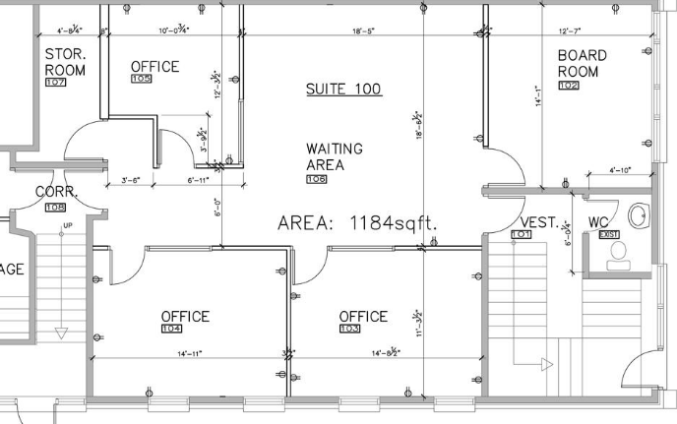
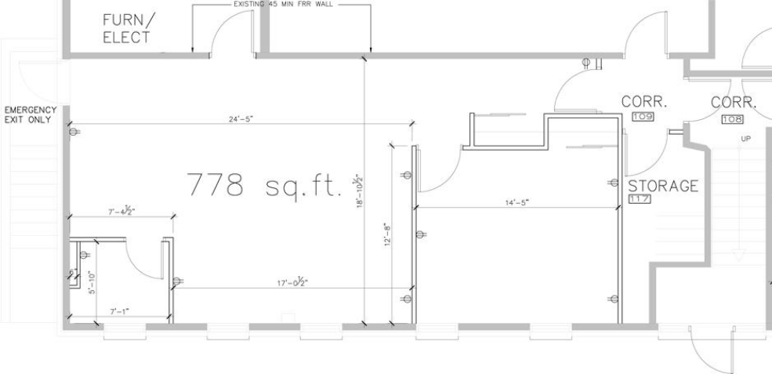

Ground Level Office Floor Plan

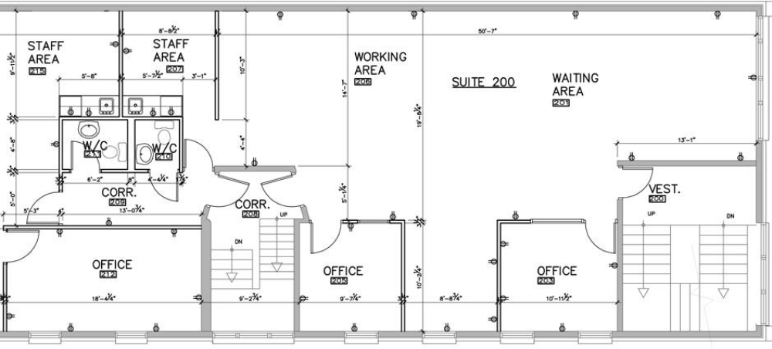
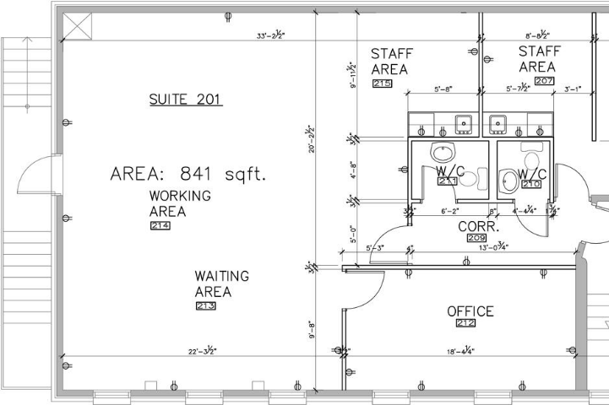

First Floor Office Plan

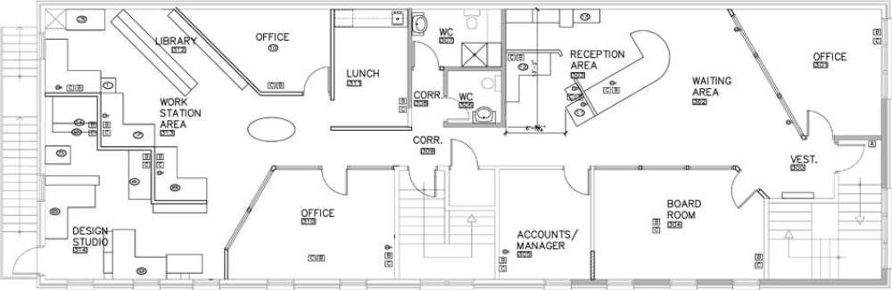
Second Floor Office Plan

(Plans adapted from //habibenterprises.ca/habib_building/plans)

